 |  | White Paper
STRATEGIC ADVANTAGES AND INNOVATION 2021

About AUSROAD

Established in 1990, the privately owned AUSROAD Group has expanded from Australian Road Maintenance plant manufacturing into specialised mining plant vehicles. With continuity of ownership over 30 years, and a dedication to the products they design and deploy. AUSROAD now counts many top tier resource companies as clients around the world. They operate in domestic and international markets across Australia, Africa, Asia, and South America.

Their expansion has developed new technology, systems, and partnerships with key organisations in the road maintenance and mining industries. All AUSROAD equipment is therefore manufactured with a deep understanding of industry requirements: maximum safety, extreme reliability and made with the highest quality to ensure minimal downtime.

A huge part of their success is continuity of parts supply, maintenance, and ongoing innovation of their products. With manufacturing locations in Australia and the Philippines, and in-house engineering, AUSROAD meets the needs of multiple international markets alongside the Australian base. They have 3 decades of design and manufacturing experience, dedication to their service and technology, and have grown to be the industry leader in their sector.

Ausroad values are stated below:

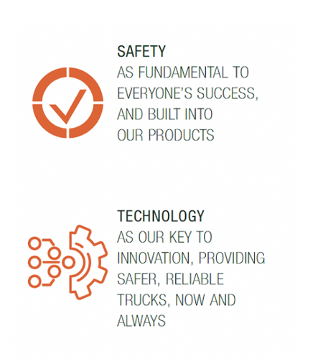
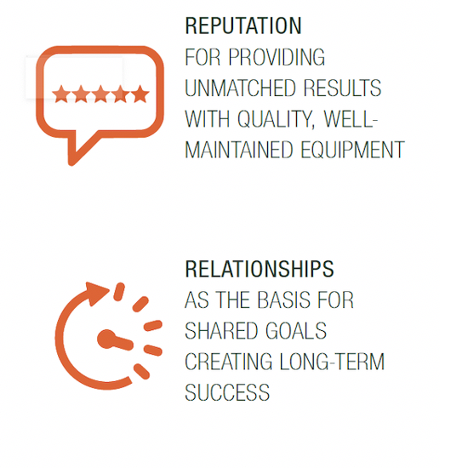
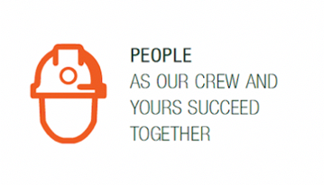

FROM PAST PERFORMANCE TO FUTURE GOALS

AUSROAD’s Premier Past Performance:
Over 5 years, they estimate AUSROAD trucks have delivered 1.8 million tons of Stemming material for a major mining client, operating over five sites. In that context, they are proud to have exceeded their contract stretch KPIs for fleet downtime in the last 12 months, with 95.7% availability of AUSROAD Water Trucks and 98.5% availability of AUSROAD Stemming Trucks.
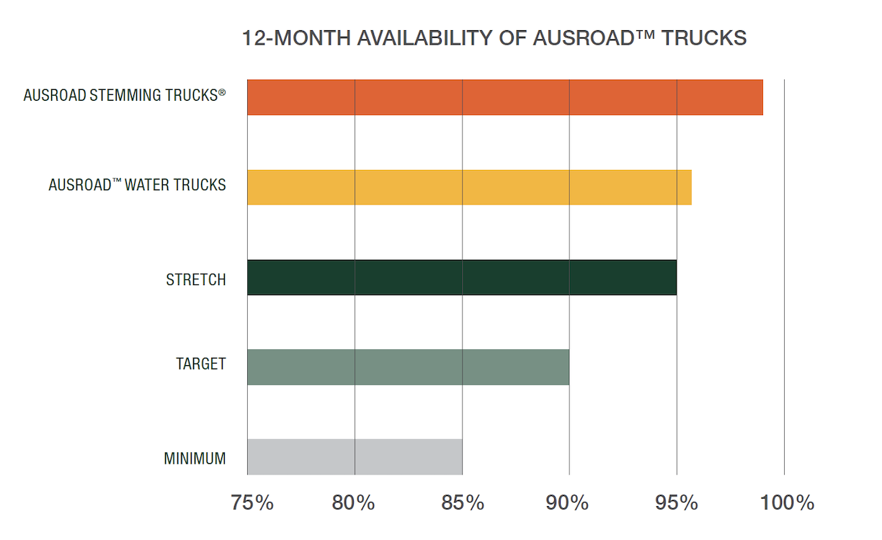

The Stemming and backfilling process is critical to production, so the 98.5% availability is a significant achievement for AUSROAD and a major benefit for your performance. AUSROAD have been proactive in achieving this result, providing ‘jump -up’ trucks during period of high demand to assist with production.

AUSROAD is therefore confident in their services and ability to exceed the current contract KPIs.

DataBlast, BlastLogic Integration and GPS Auto Location

AUSROAD is about to release its third-generation control system into their new AUSROAD Stemming Trucks, which features automated download of blast loading plans from DataBlast and BlastLogic into the truck control system.

This enables:

- Safer operation on the bench through less in-cab input from the operator
- Faster delivery and more accurate implementation of blast plans
- Improved accuracy with fewer human errors in the amounts of stemming delivered
- Reduced potential errors in other areas, such as stemming an unloaded blast hole

With the system retrofittable into the current fleet, AUSROAD offers their customers this advantage in all trucks involved in an ongoing partnership.

Automated Blast Hole Measurement

Everyone involved in stemming knows the issues in measuring the depth of blast holes. Current methods are expensive, labor-intensive and exposure onsite personnel to potential safety risks. AUSROAD has therefore invested $100,000 (with matched Australian Government funding) in a project partnership with the University of Queensland (via UniQuest) to develop an automated system for measuring the depth of blast holes.

Prototypes are currently in testing for a system that uses a disposable down-hole device to collect data on depth, amount of water and temperature. This increases accuracy and reduced manpower for delivery to the blast pattern and data collection. This will vastly reduce human labour, expenses, and personnel exposure to risks.

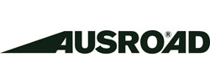





GEL STEMMING

Current Standard stemming methods have room for improvement, and to that end AUSROAD has another project with the University of Queensland investigating gel additives in stemming material.

The objectives of the new product are to:

- Reduce hard cap
- Reduce stemming material use
- Reduce fly rock
- Reduce Fume
- Reduce dust

This project is in early development and will be progressed over the next 12 months.

2021

AUSROAD will continue to strategize and innovate their equipment in 2021. They plan on the commercialization of the Automated blasthole measurement device, build an extension into blast vehicle production as well as an extension into de-water vehicle production and further refinement of water truck design.

